OPTIMIZATION

The assessment of this project was made by using the Visual Studio profiler.

The first time the project is compiled and ran, we can see that it takes too long to run. In 5 minutes, it only computed 7 steps. So, as a first assessment it is not runnable. By looking at the CPU usage of the functions we have realized that the one that produces the bottleneck is the function “particle_at()”. It is as in the function it makes a for loop to access all the elements in a list, whose memory is not contiguous. Furthermore, all the project is done by using doubles when floats do the same job and waste less memory and resources. Besides, the project properties are not set so that the project is optimized and runs faster while being more efficient.

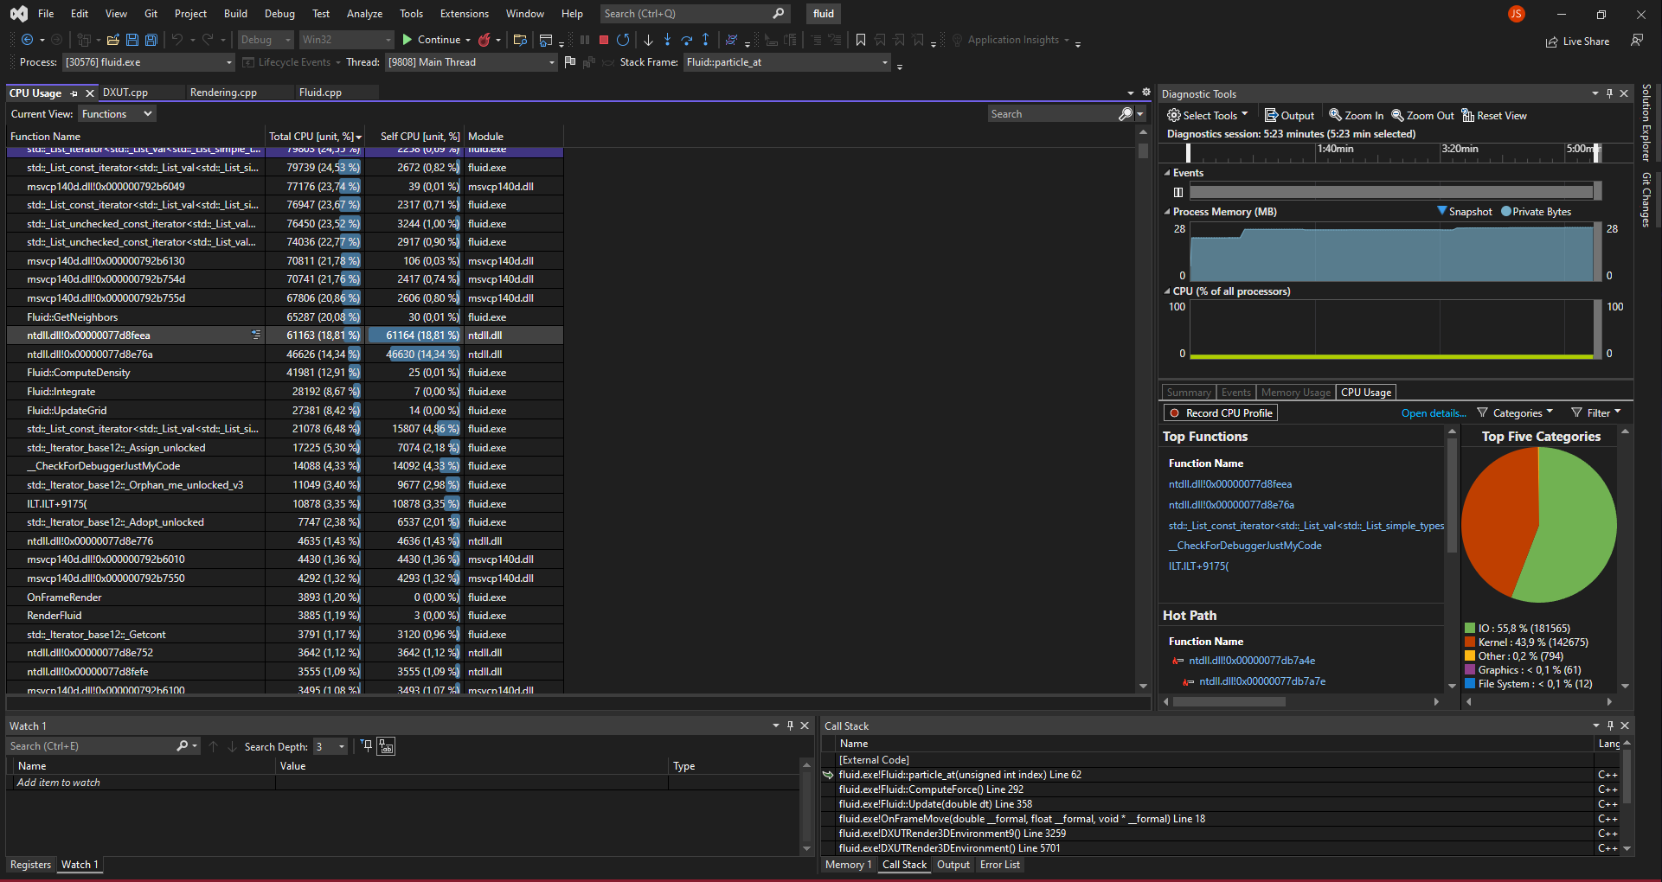



* Change nº 1

As a first change, we switch the particles from being a list to being a vector. We did that as it was the main reason why the project was taking so long to run. Of course it was also due to the particles_at() function, which every time that it was called was doing a for loop until the particle was found. If you take this and the fact that it is a list and the objects inside it are not contiguous in memory into account, you have the reason of the low runnability of the project.

Summarizing, the first change that was made was changing the particle pool from a list to a vector and completely discarding the particles_at() function by dereferencing directly the memory inside the vector.

The change was quite notorious as the project was running better than before and also, just by looking at the profiler the change was visible. As you can see below, the kernel usage went from 142675 cycles to just 16975 cycles just by making this change. This was because of the memory accessing that the list was making each time the function particle_at() was being called. Now 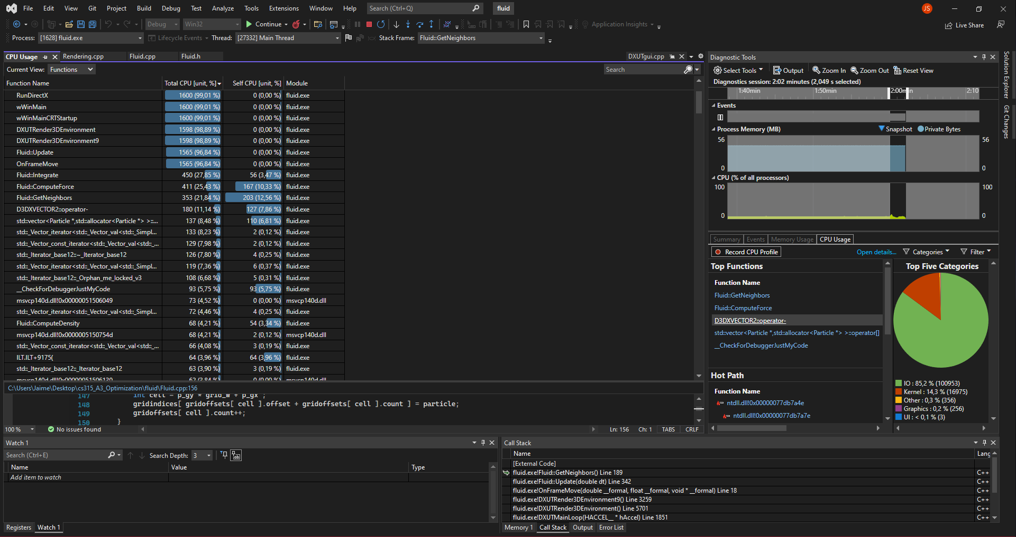the functions that waste more CPU are 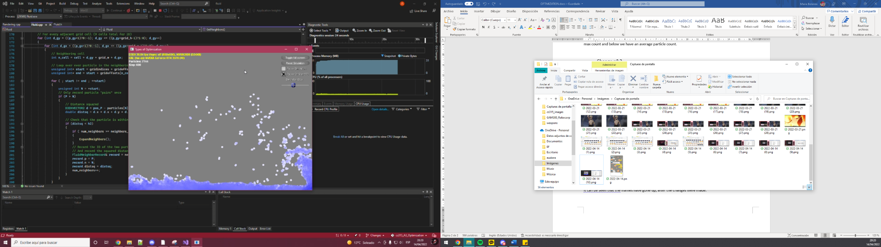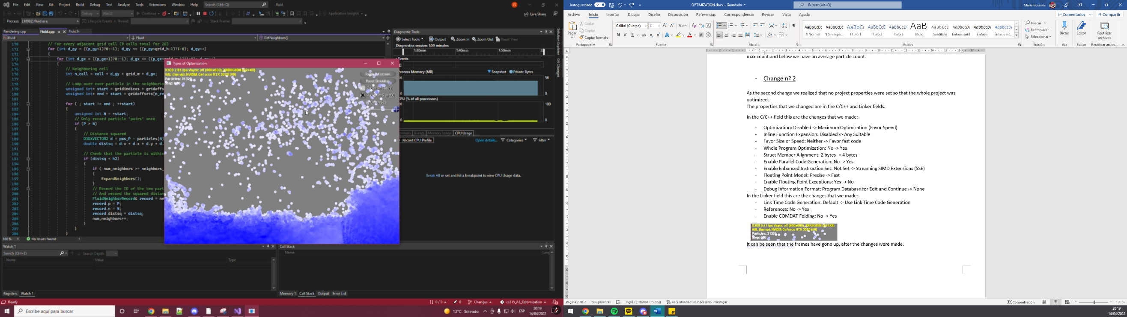functions that are written in the project code.

The change in fps is quite notorious, in both cases. On top we have the case were the particles are at max count and below we have an average particle count.

* Change nº 2

As the second change we realized that no project properties were set so that the whole project was optimized.

The properties that we changed are in the C/C++ and Linker fields:

In the C/C++ field this are the changes that we made:

* **Optimization**: Disabled -> Maximum Optimization (Favor Speed)
* **Inline Function Expansion**: Disabled -> Any Suitable. With this option we can speed up the execution by eliminating function call overhead and is useful for functions that are frequently called.
* **Enable Intrinsic Functions**: No -> Yes.
* **Favor Size or Speed**: Neither -> Favor fast code. The same as with the previous option, we specify that we care more about execution speed than code size.
* **Whole Program Optimization**: No -> Yes
* **Struct Member Alignment**: 2 bytes -> 4 bytes. This way the alignment adjusts better to the variable type we use like int or floats (one of the next changes is going to be to change all the doubles to floats).
* **Enable Parallel Code Generation**: No -> Yes
* **Enable Enhanced Instruction Set**: Not Set -> Streaming SIMD Extensions (SSE). This is helpful since one of the other optimization changes is going to be based on SIMD’s SSE
* **Floating Point Model**: Precise -> Fast. Here we care more about floats being fast and not precise. The simulation uses a lot of float arithmetic, and this option saves a lot of CPU usage.
* **Enable Floating Point Exceptions**: Yes -> No. This option must be set in order to use the previous one.
* **Debug Information Format**: Program Database for Edit and Continue -> None. For the optimization options to be set, this must be disabled.

In the Linker field this are the changes that we made:

* **Link Time Code Generation**: Default -> Use Link Time Code Generation. This option must be set in order to use the Whole Program Optimization one.

Before:

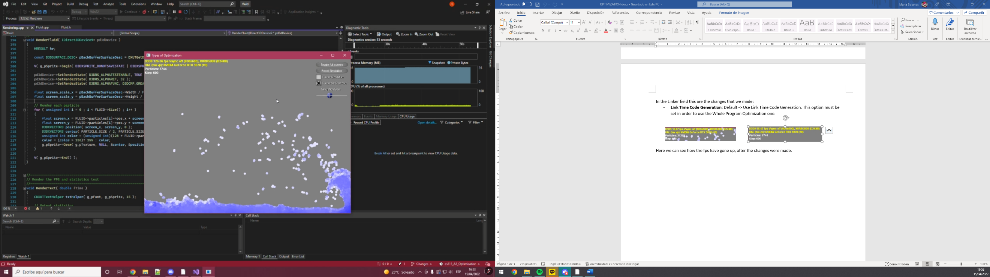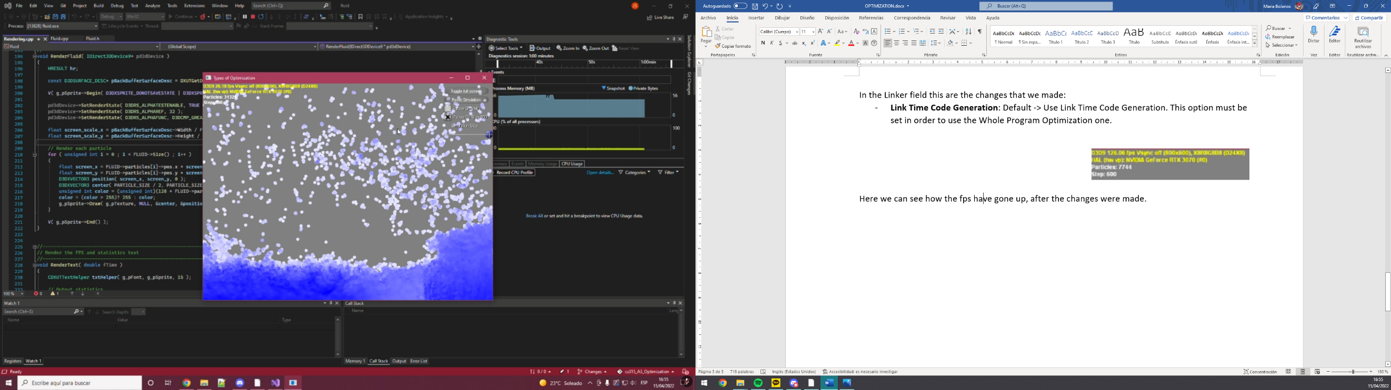After

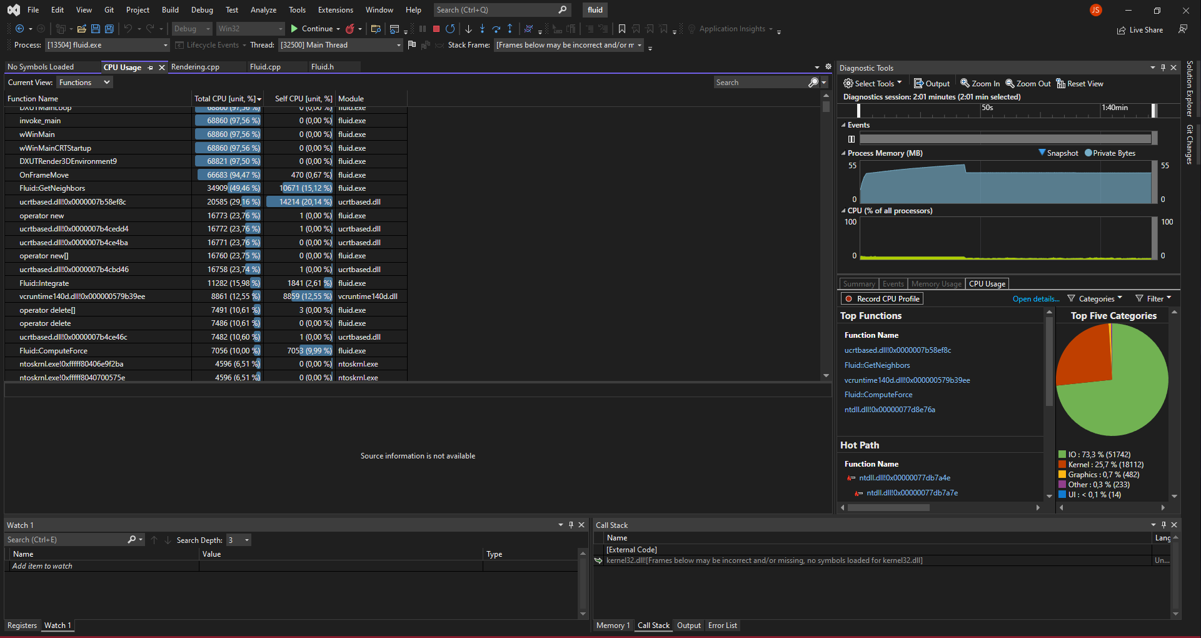

The CPU and Kernel have been reduced compared to the previous change.

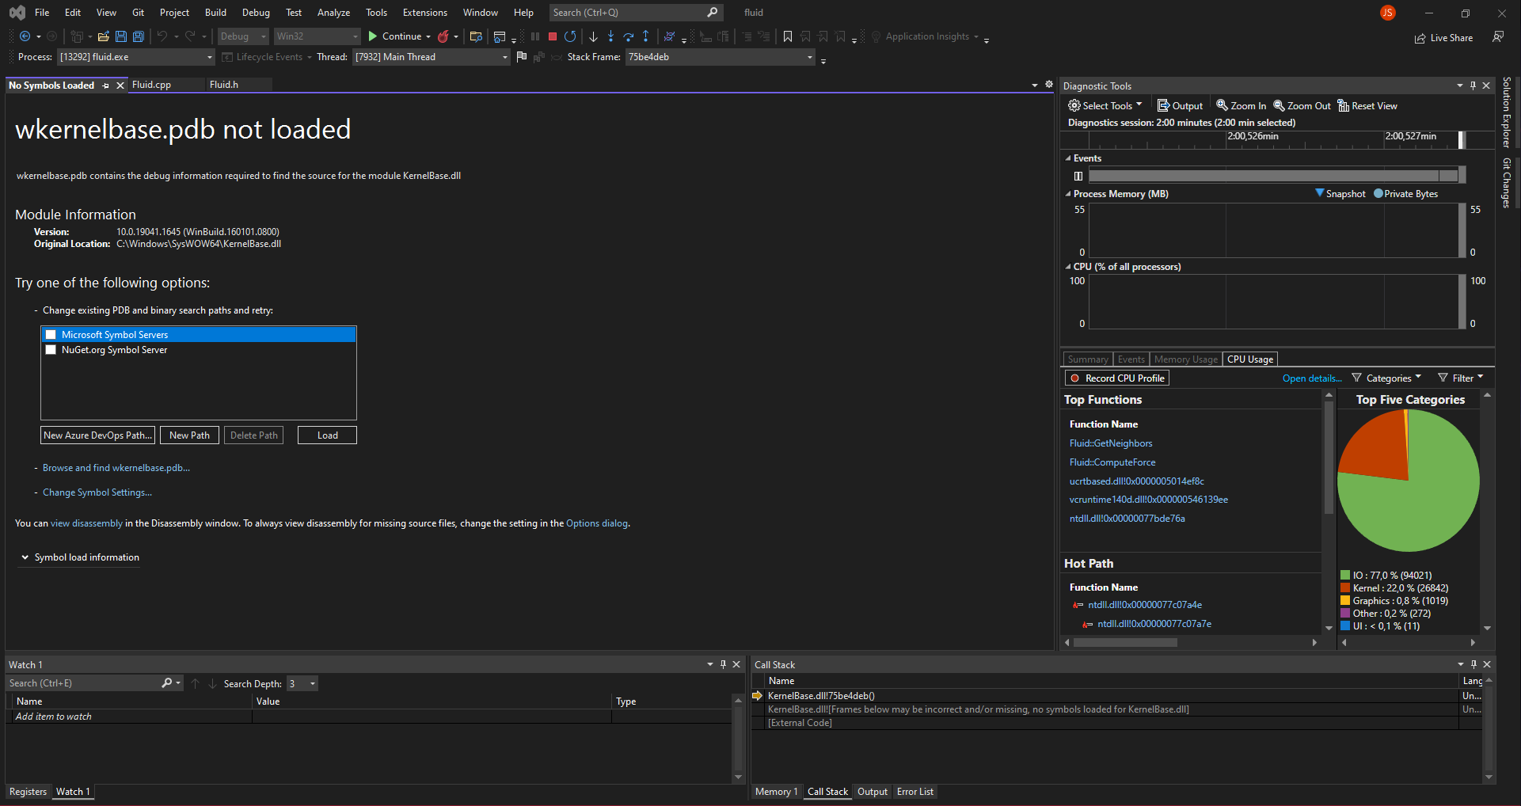Here we can see how the fps have gone up, after the changes were made.

The CPU and Kernel have been reduced compared to the previous change.

* Change nº3

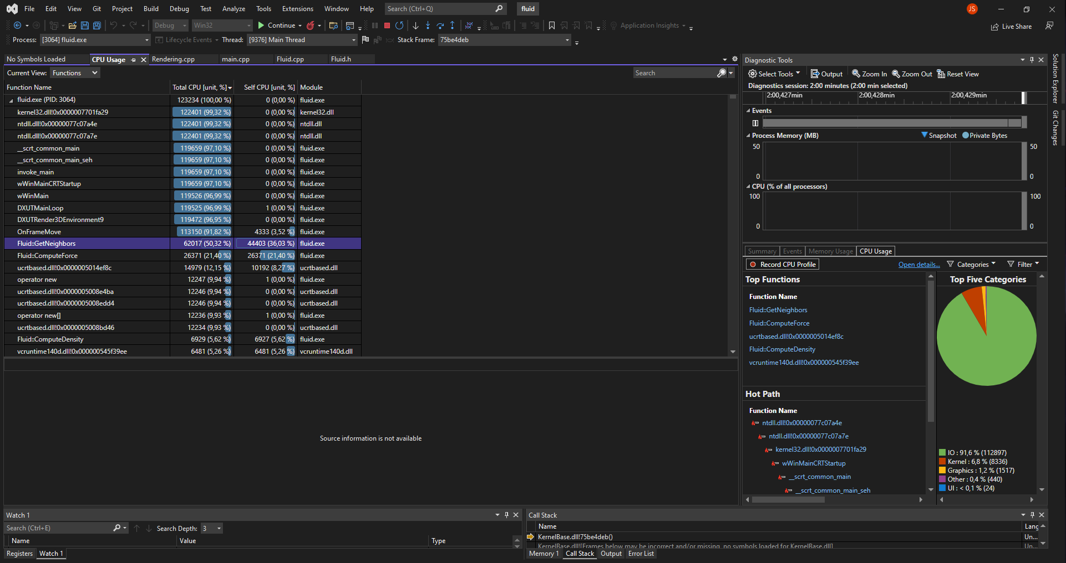After looking at the profiler the function Integrate was wasting quite some resources. It is a really small function that only does mathematical operation, so it did not made sense why it was wasting so much. We realized that a vector was being created every time the function was being called and 4 push backs were being made with the planes, which were always the same. We decided to declare the vector in the .h and to do the 4 push backs in the CreateFluids() function, as it is called once. But the waste not only coming from that, but the planes vector was also being iterated for each particle and was iterating trough the beginning and end of the vector which is what was wasting a lot of resources. Instead of that, iterating while increasing a counter and dereferencing the memory of the vector directly is a much better option, which is the change we made.

The Kernel cycles have gone down quite a bit.

Before:

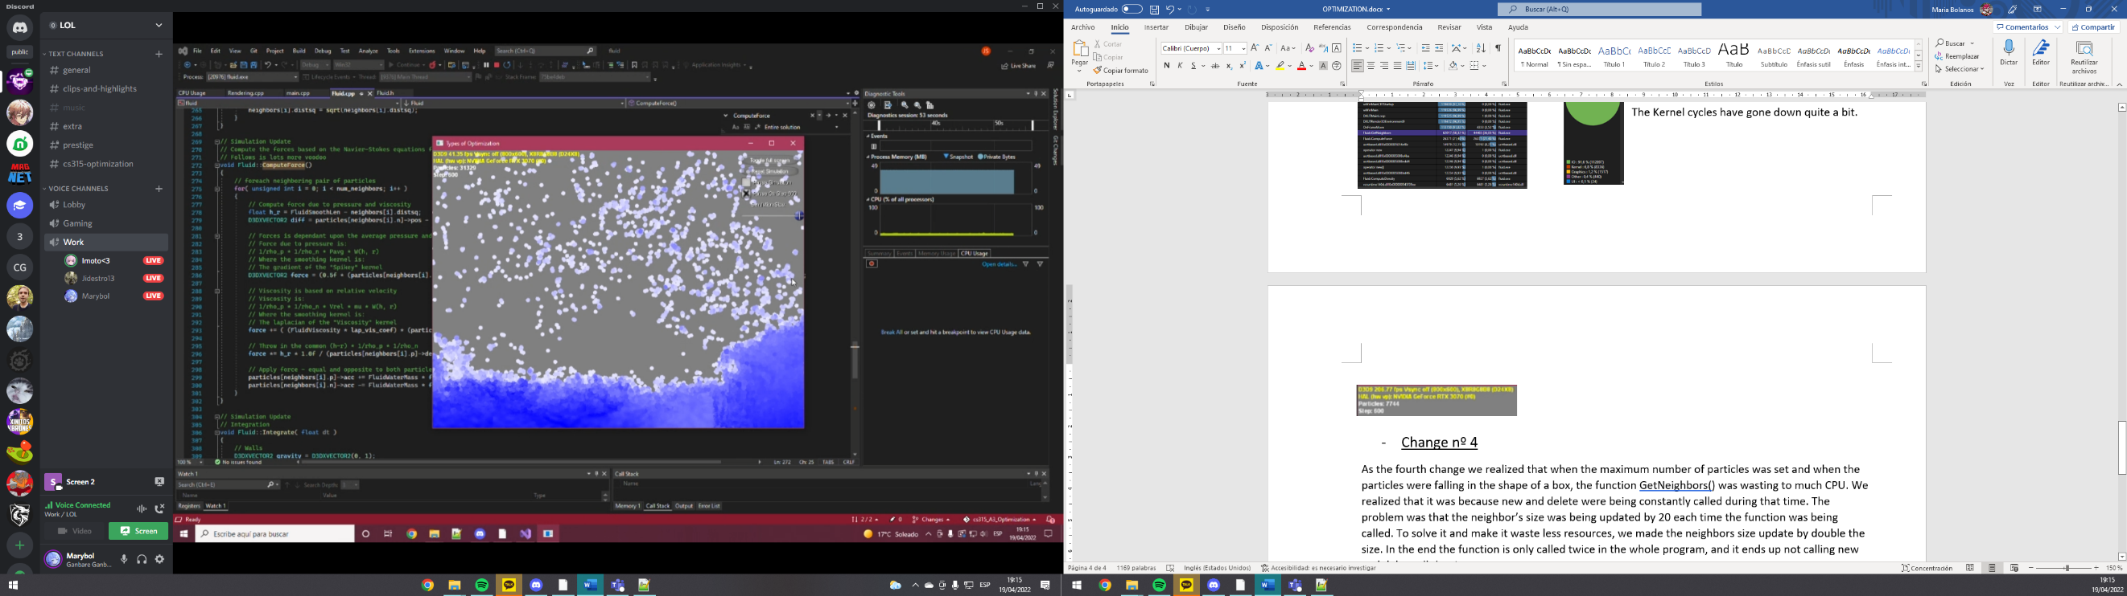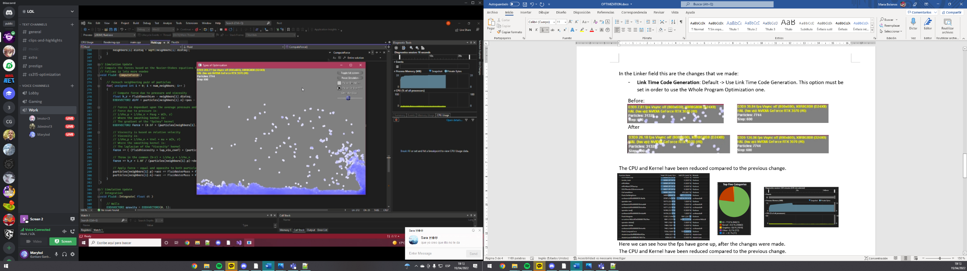After:

* Change nº 4
* Change nº 5

As the fourth change we realized that when the maximum number of particles was set and when the particles were falling in the shape of a box, the function GetNeighbors() was wasting to much CPU. We realized that it was because new and delete were being constantly called during that time. The problem was that the neighbor’s size was being updated by 20 each time the function was being called. To solve it and make it waste less resources, we made the neighbors size update by double the size. In the end the function is only called twice in the whole program, and it ends up not calling new and delete all the time.

To sum up, we decided that it was better to increase the memory a bit than to call new and delete almost every frame.

Before:

After:

* Change nº 6

For the third change we realized that the entire project was using doubles. It is not completely wrong to use them but for this simulation floats are better. They waste less space in memory and doing computation with them is much cheaper. This project does not need that much precision as to need the use of doubles, floats are more than enough.

Apart from that, in the properties we change that the struct member alignment was changed from 2 bytes to 4 bytes which is exactly the size of a float. So, memory wise it is a much better idea to change from double to floats.

* Change nº 7